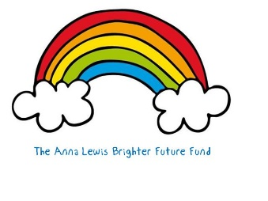
Setting up your own Justgiving Page linked to The Anna Lewis Brighter Future Fund
We would absolutely love it if you decided to fundraise for The Anna Lewis Brighter Future Fund - thank you!
The most important thing is that your Justgiving page is linked to Anna's Fund (so that any money raised goes into her fund), so here's how to do that:
Step 1
- Go to: https://www.justgiving.com/remember/26325/Anna-Lewis scroll down and then click on ‘Create your own’.
- Under ‘search for the cause you want to support’, type ‘Great Ormond Street Hospital’ and then click the search symbol. Great Ormond Street Hospital Children’s Charity will appear in the list of charities below; click the blue ‘select’ button.
Step 2
- On the next page, scroll down to ‘looking for something else’ and under ‘remembering someone’ click the blue ‘start’ button.
Step 3
- On the next page, you should see Anna’s details come up. Choose your fundraising page web address. This can be anything you like, but the easier it is for people to remember, the better!
- Choose ‘yes my page can claim GiftAid’.
- Choose whether you want to opt in or out of emails.
- Click on the blue ‘create your page’ button at the bottom of the page.
- Now don't forget to send this link out to family and friends and share on social media!
GOOD LUCK AND THANK YOU SO MUCH!

